Kiyo Ho (11) J.1 Faith

Acrostic Poem

Butterfly
Blue, pink and yellow butterfly.
Unique butterflies flying in the sky.
Two butterflies are red.
Three butterflies are blue.
Eyes are small.
Roaming around the garden.
Flying among the flowers.
Lying on the grass.
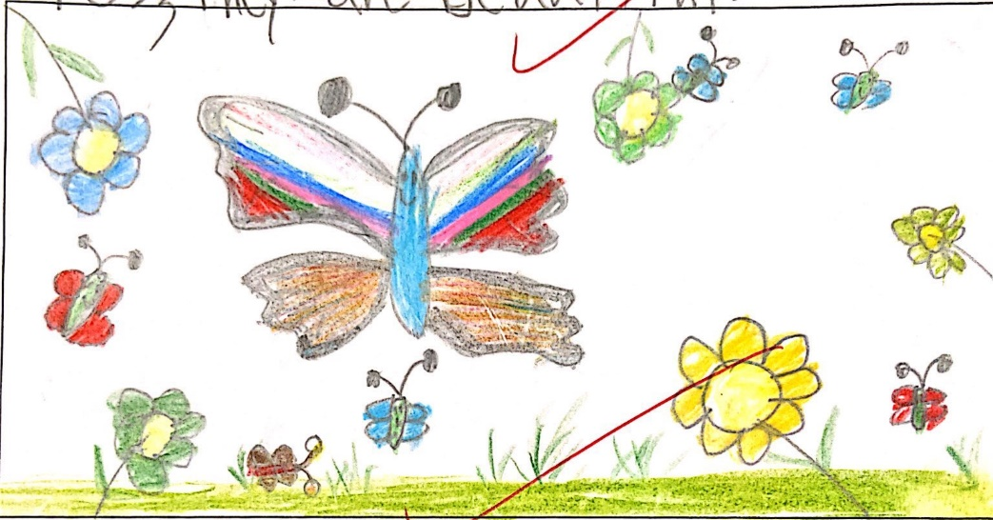
Yes, they are beautiful!

